Geography in the News 4 (2019/20)
Wider reading in Geography
Geography in the News this week covers the extreme weather event that led
to flooding across the UK in November 2019.
Support resources:
https://www.internetgeography.net/topics/uk-floods-case-study-november-2019/

Key term:
Mitigation - is any action taken to permanently eliminate or reduce the long-term risk and hazards of climate change to human life, property.

The Facts
What caused flooding in November 2019?

Mitigation

What has been done to mitigate flooding in the area since the 2007 floods?

How did people prepare for the floods?

What are the social, economic and environmental impacts of the flood?

How did humans respond to the hazard?
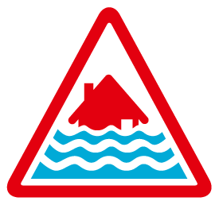

The Links - https://www.internetgeography.net/homework/synoptic-links-in-geography/
🔲 How does this article link to what you have previously studied in geography and/or what you already know? How does this link to other aspects of geography?

The next level
🔲 Create a case study infographic to summarise flooding in Yorkshire or compare the impact of the floods in 2019 with those of 2007.

