Geography in the News 6 (2019/20)
Wider reading in Geography
Geography in the News this week examines deforestation around the world.
Support resources:
https://www.theguardian.com/environment/2019/nov/24/the-five-areas-of-deforestation-amazon-ethiopia-siberia-papua-south-sudan
Short link: https://tinyurl.com/5-deforestation

The Facts – Read the article above. Present the key facts using the map below.

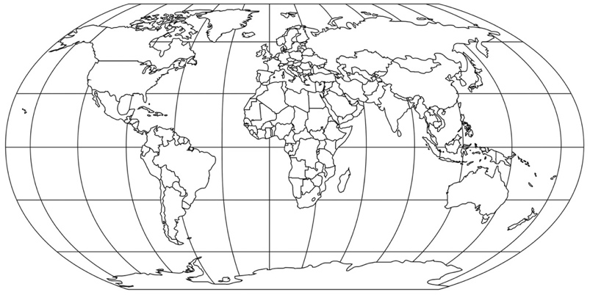

The Links - https://www.internetgeography.net/homework/synoptic-links-in-geography/
How does this article link to what you have previously studied in geography and/or what you already know? How does this link to other aspects of geography?
The next level – Take a look at the map that shows the main causes of deforestation around the world: https://tinyurl.com/gfwmap Describe the geographical patterns shows on the map and give reasons for these.

