6 |  | Interdependence | Value of TRF | Desertification |  | Producer
5 | Mineral extraction | 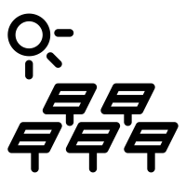 | Global ecosystems | High pressure | Selective logging and replanting
4 | Conservation and education | 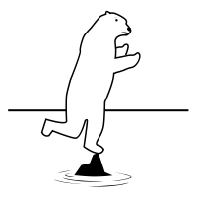 | 250mm | 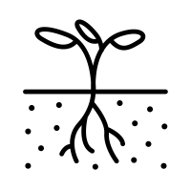 | 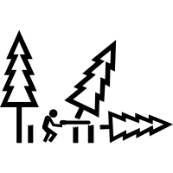 | Ecotourism
3 | Thar | Over 50 degrees Celsius. | 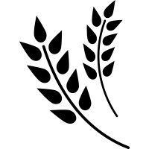 | 45% by 2030 | 8 million km squared | Energy development
2 | Low pressure | 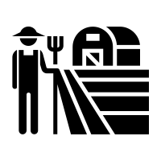 | TAW |  | Food web | Debt reduction
1 | 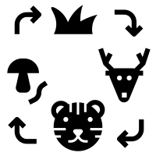 | Population growth | 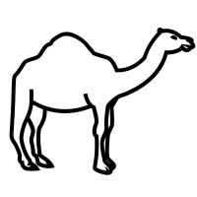 | 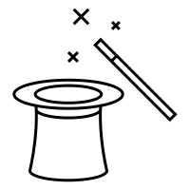 | Consumer
 | 1 | 2 | 3 | 4 | 5 | 6

Geography Learning Grid: Living World
6 |  | Interdependence | Value of TRF | Desertification |  | Producer
5 | Mineral extraction |  | Global ecosystems | High pressure | Selective logging and replanting
4 | Conservation and education |  | 250mm |  |  | Ecotourism
3 | Thar | Over 50 degrees Celsius. |  | 45% by 2030 | 8 million km squared | Energy development
2 | Low pressure |  | TAW |  | Food web | Debt reduction
1 |  | Population growth |  |  | Consumer
 | 1 | 2 | 3 | 4 | 5 | 6

Geography Learning Grid: Living World

