Geography in the News 13 (2019/20)
Wider reading in Geography
Geography in the News this week examines the outbreak of coronavirus.

This week you are to complete independent research into the coronavirus.

Geographical Questions - To get started, create geographical questions you will research about the coronavirus. Need help? Take a look here: www.internetgeography.net/asking-geographical-questions/

What caused the outbreak?

The Facts – Research the coronavirus and answer your geographical questions.

Map It – Create a choropleth map to show the global distribution (spread) of confirmed cases of the coronavirus. Create a key and shade each country according to the number of confirmed cases. There is an example for confirmed cases in China below.
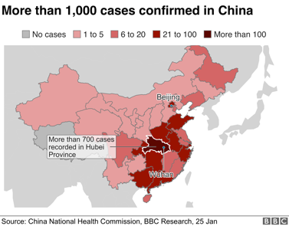
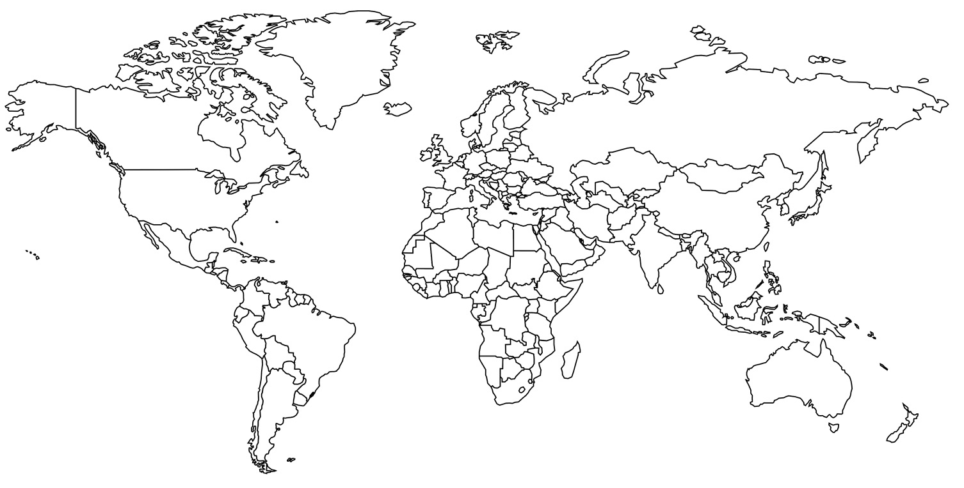

The Impacts – What are the social, economic and environmental impacts of the coronavirus?
Social Impacts | Economic Impacts | Environmental Impacts
The Links - https://www.internetgeography.net/homework/synoptic-links-in-geography/
How does this article link to what you have previously studied in geography and/or what you already know? How does this link to other aspects of geography?

The next level – Explain the importance of geographers studying major outbreaks like the coronavirus.

