Geography in the News 15 (2019/20)
Wider reading in Geography
Geography in the News this week explores the cause and effects of Storm Ciara. There are a range of resources to support you with this homework on Internet Geography. Spend some time reading the information and watching videos on this page:
https://www.internetgeography.net/topics/storm-ciara/
Define It

To begin with, it will be very useful is know what the following terms mean. Write a definition for each:
Atlantic Depression

Low pressure

The Jet Stream

The Facts

Storm Kiera is an example of a frontal depression. Read this page about the formation of frontal depressions and complete a step by step guide to their formation.
https://www.bbc.co.uk/bitesize/guides/zstcv9q/revision/2

The Map

The weather map below shows the UK at 12pm on Sunday 9th February 2020 when Storm Ciara was passing over the UK. Label the main features of the map along with the type of weather you would expect to see based on the fronts and air pressure. If you need help, take a look at www.internetgeography.net/topics/atlantic-depressions-and-the-british-isles/
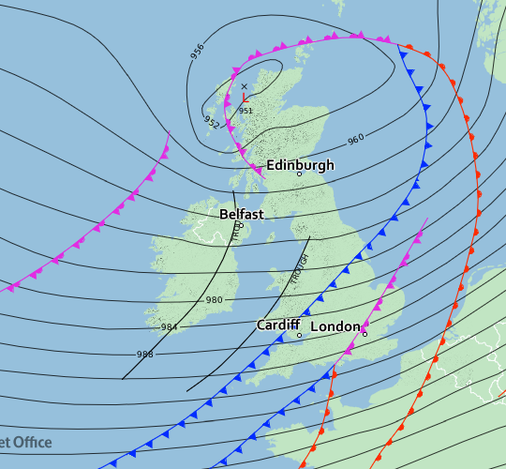
The Impacts

What are the social, economic and environmental impacts of Storm Ciara?
Social Impacts | Economic Impacts | Environmental Impacts
The Links

https://www.internetgeography.net/homework/synoptic-links-in-geography/
How does this Geography in the News link to what you have previously studied in geography and/or what you already know? How does this link to other aspects of geography?
The Next Level

Is the UK’s weather becoming more extreme?

