Geography in the News 16 (2019/20)
Wider reading in Geography
Geography in the News this week explores the floods caused by Storm Dennis. To get started have a read of this article on The Guardian website:
https://www.theguardian.com/environment/2020/feb/17/storm-dennis-floods-everything-you-need-to-know
TinyURL: https://tinyurl.com/dennisfloods

Define It

To begin with, it will be very useful is know what the following terms mean. Write a definition for each:
Flood defences

Flood plain

Natural flood management

The Facts

- How severe were the floods?
- Did flood defences fail?
- How can planning policies reduce the impact of flooding?
- Identify three approaches to natural flood management.
- How can natural flood management strategies reduce flooding?
- Identify how flood prediction is set to improve.
- Identify the priority areas for flood protection.
- Describe the graph showing spending on flood and coastal erosion risk management.
- Why has there been so much flooding recently?
- What is the impact of climate change on flooding in the UK?

The Map

The map below shows some of the areas in England and Wales most affected by flooding caused by Storm Dennis. Describe the distribution of the areas most affected by flooding.
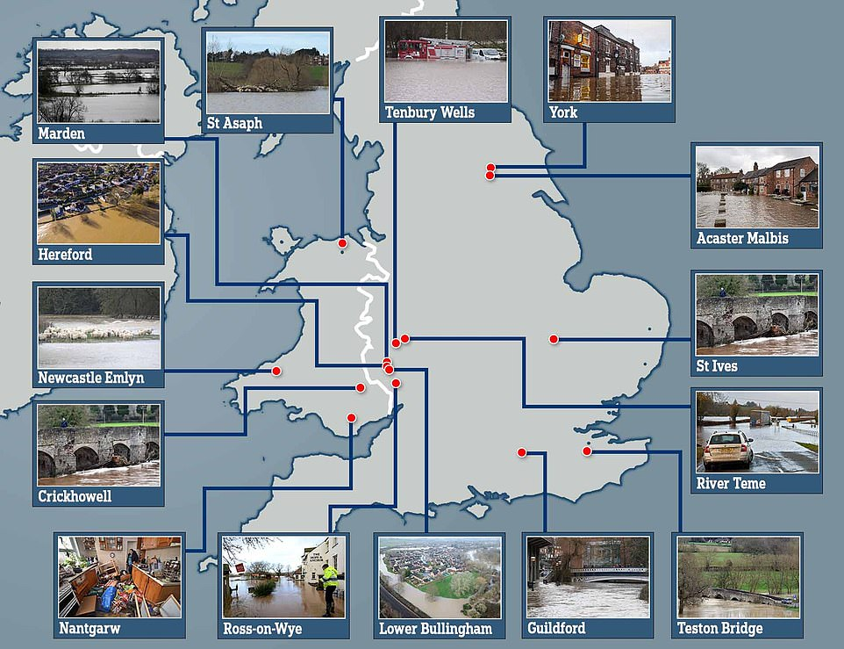
The Impacts

What are the social, economic and environmental impacts of Storm Dennis? (you will need to research his)
Social Impacts | Economic Impacts | Environmental Impacts
The Links

https://www.internetgeography.net/homework/synoptic-links-in-geography/
How does this Geography in the News link to what you have previously studied in geography and/or what you already know? How does this link to other aspects of geography?
The Next Level

To what extent are natural flood management strategies more effective than constructive flood defenses?

