Geography in the News 17 (2019/20)
Wider reading in Geography
Geography in the News this week explores plans to build more than 11,000 homes in England on land at high risk of flooding.
https://www.theguardian.com/environment/2020/feb/23/more-than-11000-homes-to-be-built-on-land-at-high-risk-of-flooding

TinyURL: https://tinyurl.com/11000-flooding
Define It

To begin with, it will be very useful is know what the following terms mean. Write a definition for each:
Housing shortage

Flood plain

Sustainable urban drainage systems

The Facts

- How many new homes are planned to be built on land at the highest risk of flooding?
- Identify one high flood risk location where properties are planned to be built.
- How many new houses are the government aiming to build by the mid-2020s?
- Why is the government planning to build so many new homes?
- Why is flooding likely to get worse in the future?
- What is a high-risk flood area?
- Why is building on land that is prone to flooding a problem for surrounding areas?
- What issues will new homeowners face in areas prone to flooding?
- What steps have already been taken by the council covering Calderdale in West Yorkshire?

The Map

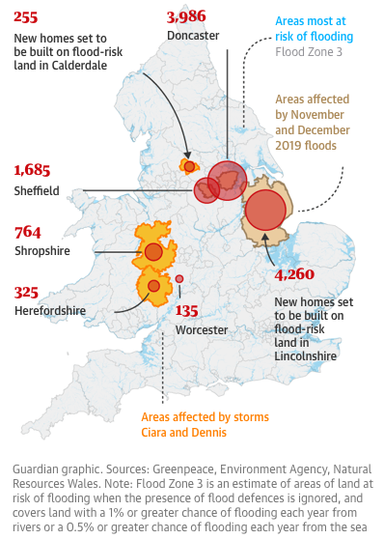
Look at the map on the webpage showing the locations of 11,410 homes due to be built over the next four years on land at high risk of flooding. Describe the distribution of the planned locations.

The Impacts

What are the social, economic and environmental impacts of building on floodplains?

Social Impacts | Economic Impacts | Environmental Impacts
The Links

https://www.internetgeography.net/homework/synoptic-links-in-geography/
How does this Geography in the News link to what you have previously studied in geography and/or what you already know? How does this link to other aspects of geography?

The Next Level

Building new houses on flood plains should be banned. To what extent do you agree with this statement?

