Geography in the News 18 (2019/20)
Wider reading in Geography
Geography in the News this week explores Indonesia’s plan to relocate its capital city from the climate-threatened megalopolis of Jakarta to the once jungle-covered island of Borneo, 800 miles away. Either watch the video below or read the information on the webpage and complete the activities.
Video:
https://www.bbc.co.uk/iplayer/episode/m000g31j/the-capital-city-sinking-into-the-sea
Video TinyURL: https://tinyurl.com/relocatejakarta
Web page:
https://www.bbc.co.uk/news/extra/xsyGF2fhsL/Indonesia_new_capital
Webpage TinyURL: https://tinyurl.com/indonesia-capital
Define It

To begin with, it will be very useful to know what the following terms mean. Write a definition for each:
- Subsiding
- Sustainable city
- Urbanisation
- Ground water
- Indigenous people
The Facts

- What is the capital city of Jakarta?
- What proportion of Jakarta will be below the sea by 2050 if nothing is done?
- What was built to hold back the sea?
- Where is the government planning to build a new capital city?
- What concerns are there about relocating the capital city?
- Why are floods getting worse in Jakarta?
- Why is Jakarta subsiding?
- How many metres below sea level is Jakarta?
- What have the government done to try to reduce the impact of coastal flooding? How effective has it been?
- What have individuals done to tackle the problem of flooding?
- How much land has been designated for the new capital city on the island of Borneo?
- How much will the relocation of Indonesia’s capital city cost and when are the government trying to complete it by?
- How are the government planning on providing energy?
- Why have large areas of tropical rainforest been cleared in Indonesia?
- What has been the impact of mining on Borneo?
- What was the transmigration project?
- How have planners designed the city to work with the natural environment?
- Why are indigenous people concerned about the development of the new capital?
- What conflicts have occurred regarding land ownership?
- Why is the rainforest important?
- What is the fastest way of clearing land in the forest? What is its impact on the environment?
- What will be the impact of moving the capital city on the poorest people in Jakarta?
The Map

Identify the location of Jakarta and the new capital city on the map below.

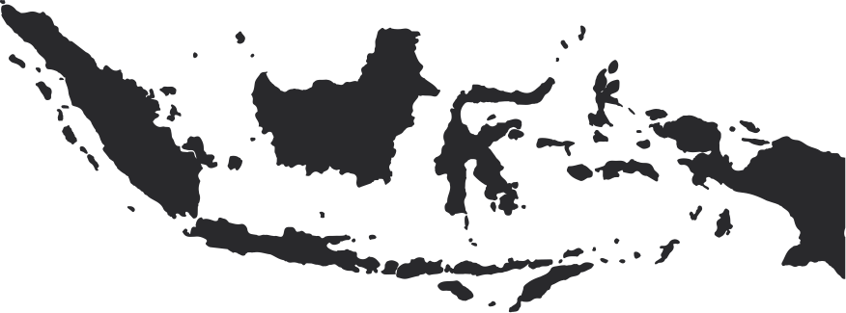
The Impacts

What are the social, economic and environmental impacts of relocating the capital city?

Social Impacts | Economic Impacts | Environmental Impacts
The Links

https://www.internetgeography.net/homework/synoptic-links-in-geography/
How does this Geography in the News link to what you have previously studied in geography and/or what you already know? How does this link to other aspects of geography?
The Next Level

The Indonesian government should relocate its capital city. To what extent do you agree with this statement?

