Geography in the News 19 (2019/20)
Wider reading in Geography
Geography in the News this week explores the resurrection of the UK’s lost sea meadows to tackle climate change. Read the news article here:
https://www.theguardian.com/environment/2020/mar/10/uk-lost-sea-meadows-to-be-resurrected-in-climate-emergency-fight
TinyURL: https://tinyurl.com/sea-meadow
Define It

To begin with, it will be very useful to know what the following terms mean. Write a definition for each:
- Seagrass

- Carbon store

- Climate crisis

- Biodiversity

The Facts

- Where is the Seagrass Ocean Rescue project currently sewing meadows?
- How many seeds have been sewn so far?
- How many seeds will be placed on the sea floor?
- What percentage of seagrass meadows have been lost around the coast of the UK?
- What caused the loss of the seagrass?
- What are the benefits of seagrass meadows?
- What proportion of carbon is stored in seagrass globally?
- How have school children supported the project?
- How were the seeds collected?
- What are the benefits of seagrass meadows?

The Map

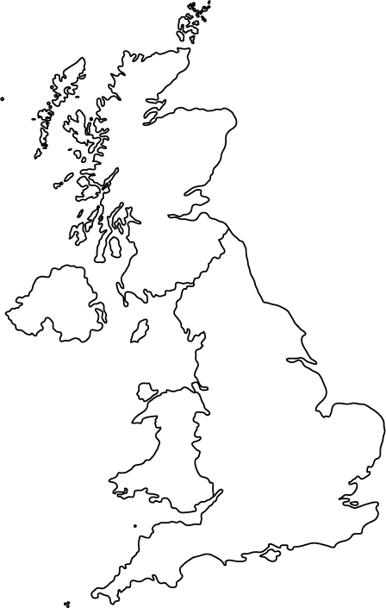
Identify the potential locations in the UK
for seagrass meadows in the future.

The Impacts

What are the social, economic and environmental impacts of seagrass meadows?
Social Impacts | Economic Impacts | Environmental Impacts

The Links

https://www.internetgeography.net/homework/synoptic-links-in-geography/
How does this Geography in the News link to what you have previously studied in geography and/or what you already know? How does this link to other aspects of geography?

The Next Level

Seagrass meadows should be sewn around the full coast of the UK. To what extent do you agree with this statement?

