Geography in the News 20 (2019/20)
Wider reading in Geography
Geography in the News this week explores whether tree planting will save the planet. Read the news article here:
https://www.bbc.co.uk/news/science-environment-51633560
TinyURL: https://tinyurl.com/tree-planting
Define It

To begin with, it will be very useful to know what the following terms mean. Write a definition for each:
- Climate change

- Carbon dioxide

- Incentives

- Sapling
- Drought

- Photosynthesis

The Facts

- How many trees have the government pledged to plant?
- What proportion of the UK will be forested when the trees have been planted?
- Why is tree planting a popular idea?
- How much CO² is absorbed by trees in the UK?
- What are the challenges associated with planting new trees in the UK?
- Describe the problems associated with the plan to plant so many trees.
- Can trees stop climate change?
- Why is it important not to plant the same species of tree in one place?
- Describe two successful international schemes that have encouraged tree planting.

The Graph

Describe the graph showing new planting in the UK. There is advice on using TEA for describing graphs here: https://www.internetgeography.net/a-technique-for-graph-interpretation-exam-questions-using-tea/
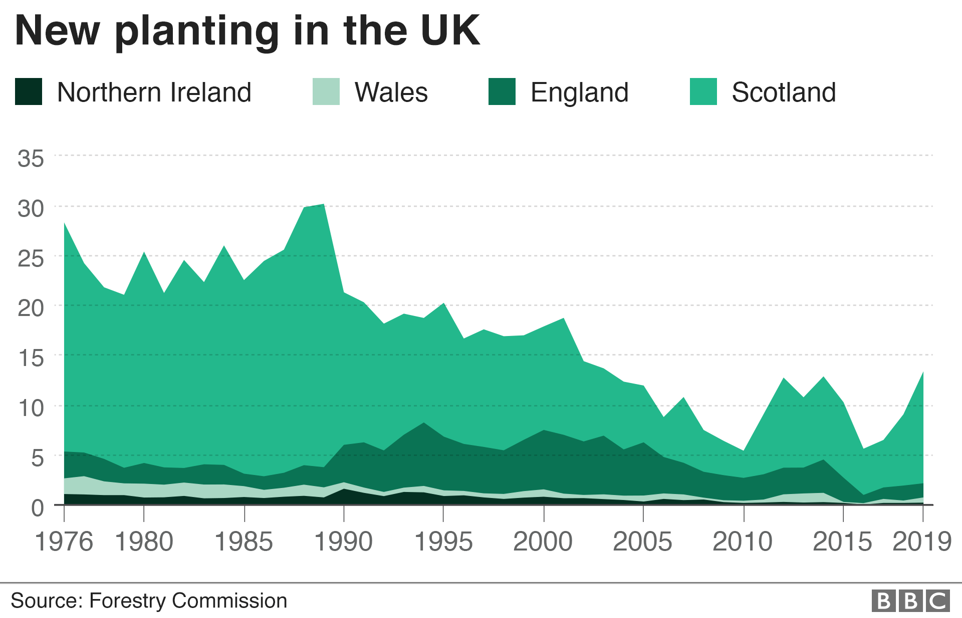
The Impacts

What are the social, economic and environmental impacts of tree planting schemes?
Social Impacts | Economic Impacts | Environmental Impacts
The Links

https://www.internetgeography.net/homework/synoptic-links-in-geography/
How does this Geography in the News link to what you have previously studied in geography and/or what you already know? How does this link to other aspects of geography?
The Next Level

The government should be more ambitious and plant more trees than they have pledged. To what extent do you agree with this statement?

