Geography in the News 21 (2019/20)
Wider reading in Geography
Geography in the News this week explores a bug that feasts on toxic plastic. Read the news article here:
https://www.theguardian.com/environment/2020/mar/27/scientists-find-bug-that-feasts-on-toxic-plastic
TinyURL: https://tinyurl.com/plasticbug
Define It

To begin with, it will be very useful to know what the following terms mean. Write a definition for each:
- Bacterium

- Polyurethane

- Carcinogenic chemicals

- Contamination
- Fungi
- Enzymes

The Facts

- In the article, what has been discovered by scientists?
- Where was the bacterium found?
- The bacterium is the first to attack which type of plastic?
- Why does so much of this type of plastic end up in landfill?
- What is the impact of polyurethane breaking down naturally?
- How long might it be before this bacterium could be used at a large scale?
- How many tonnes of plastic has been produced since the 1950s?
- Where has most of this plastic end up?
- What can the bacteria extract from the plastic?

The Graph

Describe the graph showing global plastic production. There is advice on using TEA for describing graphs here: https://www.internetgeography.net/a-technique-for-graph-interpretation-exam-questions-using-tea/
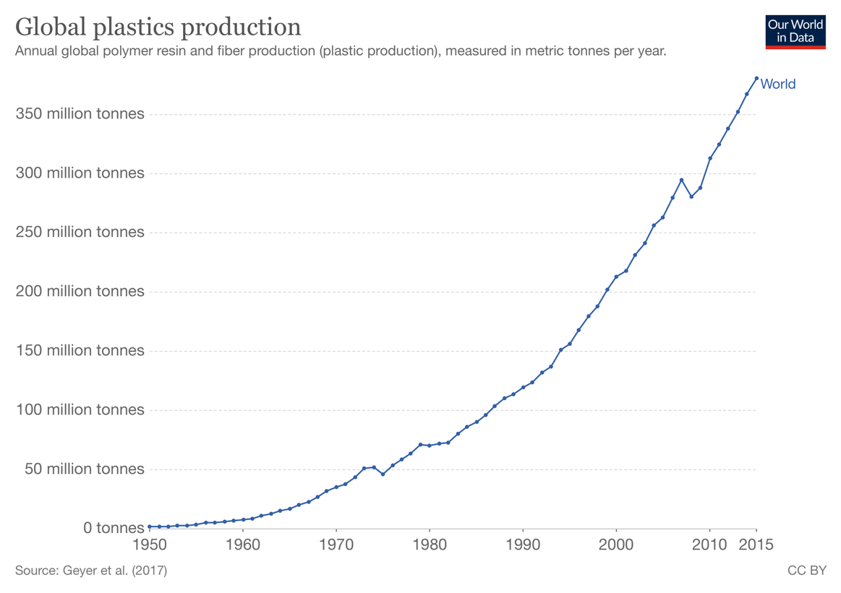
Visit https://ourworldindata.org/plastic-pollution to explore the interactive graph.
The Impacts

What are the social, economic and environmental impacts of plastic production?
Social Impacts | Economic Impacts | Environmental Impacts
The Links

https://www.internetgeography.net/homework/synoptic-links-in-geography/
How does this Geography in the News link to what you have previously studied in geography and/or what you already know? How does this link to other aspects of geography?
The Next Level

Given bacteria will be able to decompose plastic in the future, we should continue our use of it today. To what extent do you agree with this statement?

