Geography in the News 21 (2019/20)
Wider reading in Geography
Geography in the News this week explores a project to rescue the UK’s old rainfall records. Read the news article here:
https://www.bbc.co.uk/news/science-environment-52040822
Define It

To begin with, it will be very useful to know what the following terms mean. Write a definition for each:
- Digitisation

- Flooding

- Drought

- Rain gauge

- Meteorologist

The Facts

- How far back do UK rainfall records go?
- What form are most of these records in? Why is this a problem?
- How many documents has the Met Office already scanned in?
- Give an example of another weather rescue project.
- Identify the gap in digital weather records.
- Why are the team seeking to convert the data into a digital format?
- Why is it hard to come up with predictions for drought and flooding?

The Map

Look at the two maps below showing the differences in rainfall between August 1955 and August 1956. Compare and contrast (say how they are similar and different) the patterns of rainfall.
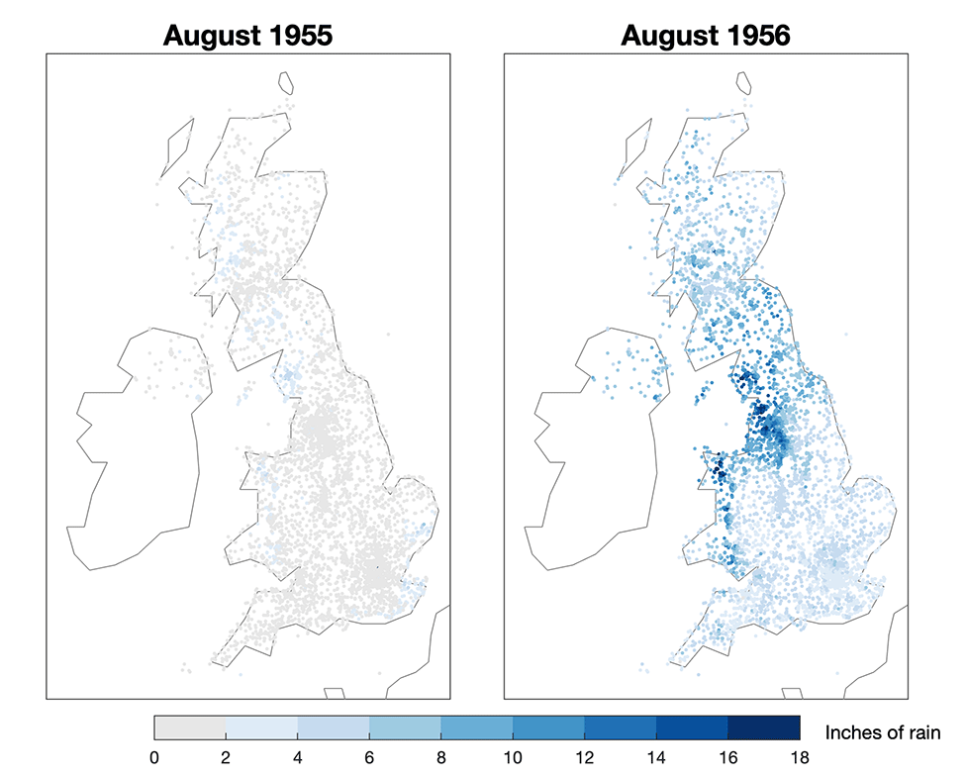
Get Involved

Have a go at digitising some rainfall data. There is a link in the article or head over to https://www.zooniverse.org/projects/edh/rainfall-rescue

The Links

https://www.internetgeography.net/homework/synoptic-links-in-geography/
How does this Geography in the News link to what you have previously studied in geography and/or what you already know? How does this link to other aspects of geography?
The Next Level

What other historical data could be digitised to help organisations such as the Environment Agency in planning for the future? Explain your answers.

