Geography in the News 23 (2019/20)
Wider reading in Geography
Geography in the News this week explores seasonal migrant workers supporting UK farmers. Read the news article here:
https://www.bbc.co.uk/news/uk-england-cambridgeshire-52300349
TinyURL: https://tinyurl.com/seasonalfarmers

Define It

To begin with, it will be very useful to know what the following terms mean. Write a definition for each:
- Migrant

- Seasonal migrant

- International migrant

- Skilled workers
- Seasonal agricultural worker
The Facts

Complete the questions below or head over to https://www.internetgeography.net/gitn23/ to complete the questions as a multiple-choice quiz.
- Where are staff being flown from to train the UK’s seasonal farming workforce?
- How many skilled workers will land on Thursday 23rd April 2020?
- How many UK-based pickers have been recruited to work from the end of April?
- What steps are being taken to reduce the risk of the spread of Coronavirus?
- How many flights could arrive by the end of June?
- Why is there a shortage of seasonal farm workers?
- What proportion of G’s workforce will be from the UK this year?
- Why are the returning seasonal workers so important?
/8
Did the quiz online? What was your score?
The Graph

Describe the graph showing the breakdown of seasonal farm workers in the UK . There is advice on using TEA for describing graphs here: https://www.internetgeography.net/a-technique-for-graph-interpretation-exam-questions-using-tea/
Or scan this

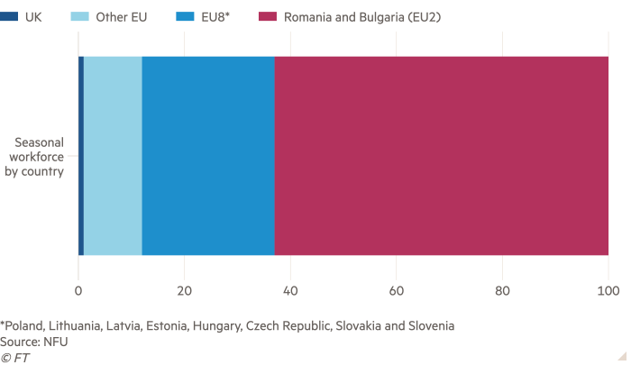
The Impacts

Need help?
What are the impacts of seasonal international migration?
 | Positive Impacts | Negative Impacts
Destination country
Home country
The Links

https://www.internetgeography.net/homework/synoptic-links-in-geography/
How does this Geography in the News link to what you have previously studied in geography and/or what you already know? How does this link to other aspects of geography?
The Next Level

Seasonal international migration is essential to the UK. To what extent do you agree with this statement?

