Geography in the News 24 (2019/20)
Wider reading in Geography
Geography in the News this week explores how reductions in air pollution during lockdown could lead to warmer weather.

https://www.independent.co.uk/environment/coronavirus-lockdown-air-pollution-warmer-weather-heatwave-nitrogen-dioxide-a9482996.html
TinyURL: https://tinyurl.com/warmerlockdown


Define It

To begin with, it will be very useful to know what the following terms mean. Write a definition for each:
- Weather
- Climate
- Air pollution

- Carbon dioxide

- Particulate matter

- Localised warming

The Facts


Complete the questions below or head over to https://www.internetgeography.net/gitn24/
to complete the questions as a multiple-choice quiz.
- What do experts believe could lead to an increase in warm weather across the country?
- During lockdown, how much have air pollution levels dropped by in many UK cities?
- Which pollutants, that have a long-term effect on climate, remain in the atmosphere for a long time?
- Give an example of a shorter-lived atmospheric pollutant.
- How can the reduction of some shorter-lived pollutants affect the weather?
- True or false? Some atmospheric particle matter is slowing down climate change.
- What are aerosols?
- Give two examples of natural and man-made aerosols.
- Give examples of how levels of air pollution have fallen in the UK.
- What is a ULEZ?
/10
Did the quiz online? What was your score?

The Map

Either describe the map below showing CO2 levels in the UK, or;
Describe (say what the map shows) and explain (the reasons for it) the the map below showing CO2 levels in the UK.
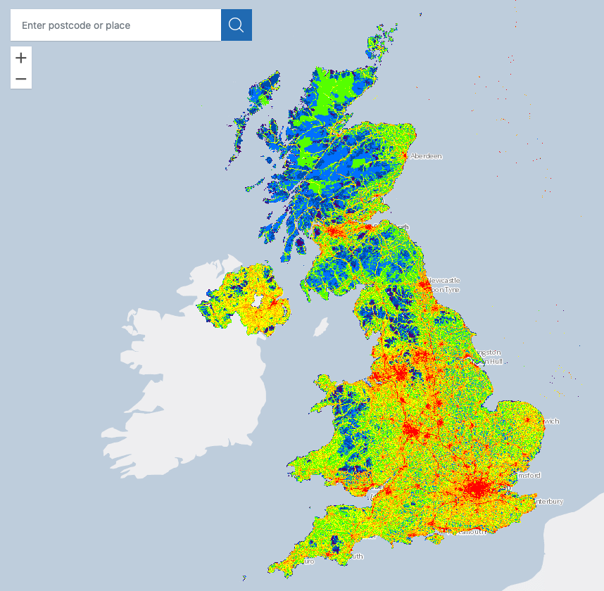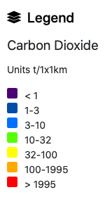

The Impacts

What are the impacts of air pollution?
 | Positive Impacts | Negative Impacts
Weather
Climate

The Links

https://www.internetgeography.net/homework/synoptic-links-in-geography/
How does this Geography in the News link to what you have previously studied in geography and/or what you already know? How does this link to other aspects of geography?

The Next Level

We should burn more trees to release aerosols into the atmosphere to combat climate change. To what extent do you agree with this statement?

