Geography in the News 25 (2019/20)
Wider reading in Geography
Geography in the News this week explores how more than 3bn people could live in extreme heat by 2070.
https://www.bbc.co.uk/news/science-environment-52543589
TinyURL: https://tinyurl.com/CC3bnHeat

Define It

To begin with, it will be very useful to know what the following terms mean. Write a definition for each:
- Climate change
- Paris Climate Agreement
- Climate niche
The Facts

Complete the questions below or head over to https://www.internetgeography.net/gitn25/
to complete the questions as a multiple-choice quiz.

- How many people will be living in new un-liveable temperatures by 2070?
- Unless greenhouse emissions fall, large numbers of people will experience average temperatures hotter than how many degrees Celsius?
- How long have humans thrived within the climate niche?
- True or false? Even people living within countries keeping to the Paris climate agreement are on course for a 3°C temperature rise.
- What is the average temperature of the narrow climate bands where the majority of the world’s population live?
- True or false? Land warms faster than the ocean so it is warming more than three degrees.
- In a 3°C warmer world, how higher will typical land-based temperatures be?
- Identify the type of people most likely to suffer due to increases in temperature?
- True or false? Limiting climate change could bring benefits in terms of reducing the number of people projected to fall outside of the climate niche.
- For every one degree of warming, how many people will be affected?
/10
Did the quiz online? What was your score?

The Graph

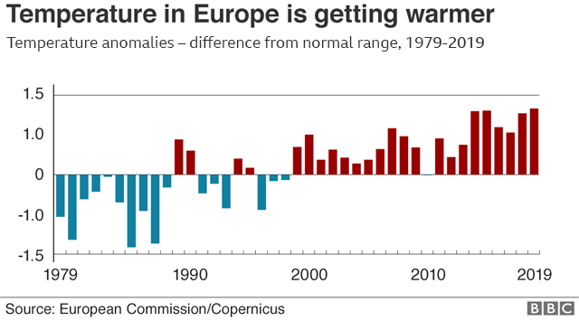
The graph above shows temperature anomolies between 1979-2019. This means the difference from the normal range in temperature. The blue bars show temperature below the normal range, the red bars show temperature above the normal range. Describe what the graph shows. There is advice on using TEA for describing graphs here: https://www.internetgeography.net/a-technique-for-graph-interpretation-exam-questions-using-tea/
The Impacts

What are the impacts of increasing global temperatures?
Positive Impacts | Negative Impacts
The Links

https://www.internetgeography.net/homework/synoptic-links-in-geography/
How does this Geography in the News link to what you have previously studied in geography and/or what you already know? How does this link to other aspects of geography?
The Next Level

Everyone has a role to play in reducing carbon emissions. To what extent do you agree with this statement?

