Geography in the News 26 (2019/20)
Wider reading in Geography
Geography in the News this week explores the surge in deforestation in the Brazilian Amazon.
https://www.bbc.co.uk/news/world-latin-america-52595030
TinyURL: https://tinyurl.com/amazon-gitn
Define It

To begin with, it will be very useful to know what the following terms mean. Write a definition for each:
- Deforestation
- Illegal logging

- Rancher

- Carbon store

- Conservation group

- Non-profit conservation group
The Facts

Complete the questions below or head over to https://www.internetgeography.net/gitn26/
to complete the questions as a multiple-choice quiz.
- How is Brazil responding to an increase in deforestation in the Amazon rainforest?
- Identify two causes of increased deforestation in the Amazon.
- How much greater was the scale of deforestation in April 2020 compared to the same period one year ago?
- In the first four months of 2020, how much did the destruction of the forest by illegal loggers and ranchers rise by?
- What is the global importance of the Amazon rainforest?
- How many sq km of rainforest was deforested during April 2020?
- How many more sq km of rainforest was deforested compared to April 2019?
- What has been the impact of Covid-19 on the Amazon rainforest?
- What is Ibama?
- What has been the policy of the Brazilian president towards the Amazon rainforest?
/10
Did the quiz online? What was your score?

The Graph

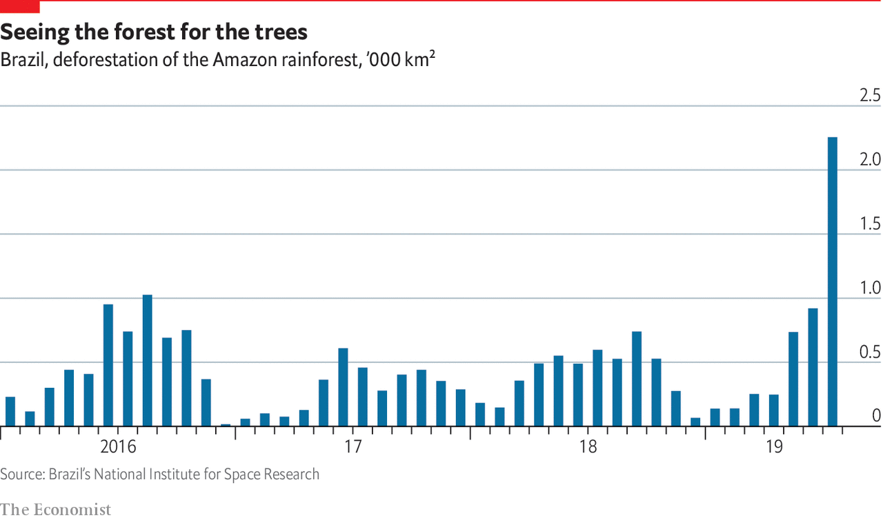
The graph above shows rates of deforstation in the Amazon rainforest. Describe what the graph shows. There is advice on using TEA for describing graphs here: https://www.internetgeography.net/a-technique-for-graph-interpretation-exam-questions-using-tea/
The Impacts

What are the impacts of deforestation in the Amazon?
Positive Impacts | Negative Impacts
The Links

https://www.internetgeography.net/homework/synoptic-links-in-geography/
How does this Geography in the News link to what you have previously studied in geography and/or what you already know? How does this link to other aspects of geography?
The Next Level

Brazil have a global responsibility to protect the rainforest. To what extent do you agree with this statement?

