Geography in the News 27 (2019/20)
Wider reading in Geography
Geography in the News this week explores new plant-based bottles that will degrade in a year.
https://www.theguardian.com/environment/2020/may/16/the-end-of-plastic-new-plant-based-bottles-will-degrade-in-a-year
TinyURL: https://tinyurl.com/plant-bottles
Define It

To begin with, it will be very useful to know what the following terms mean. Write a definition for each:
- Sustainably grown crops
- Renewable chemicals

- Plant plastic

- Fossil fuels

- Plastic pollution
- Decompose
The Facts

Complete the questions below or head over to www.internetgeography.net/gitn27/
to complete the questions as a multiple-choice quiz.
- Which multinational companies have backed a pioneering project to make ‘all-plant’ drinks bottles?
- What is plastic traditionally made from?
- What will be used to produce the new ‘all-plant’ bottles?
- Where is the biochemicals company that plans to produce the ‘all-plant’ bottles located?
- Why has the project got the backing of major companies?
- How many tonnes of plastic is made from fossil fuels each year?
- How long can microplastics take to decompose completely?
- How long would the plastic take to decompose using a composter?
- When could be the product be on supermarket shelves?
- How much plastic will the project initially produce?
Did the quiz online? What was your score? /10
The Graph

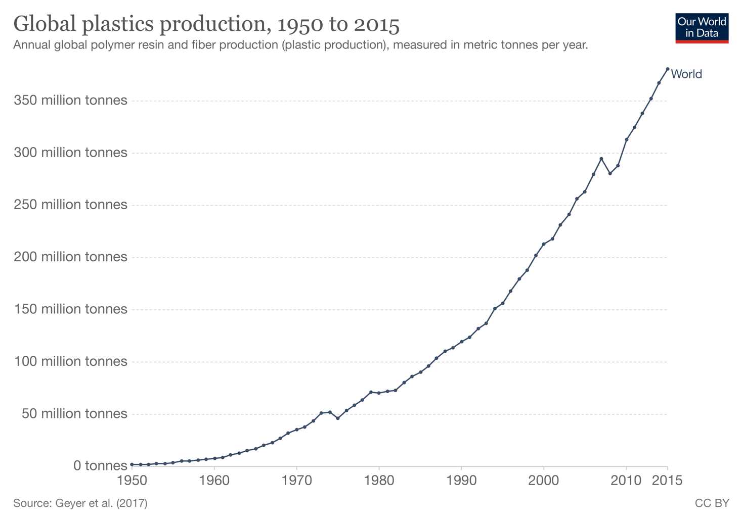
Interactive graph here: https://ourworldindata.org/grapher/global-plastics-production
The graph above shows the global rate of plastic production between 1950 to 2015. Describe what the graph shows. There is advice on using TEA for describing graphs here: https://www.internetgeography.net/a-technique-for-graph-interpretation-exam-questions-using-tea/
The Impacts

What are the impacts of plastic production?
Positive Impacts | Negative Impacts
The Links

https://www.internetgeography.net/homework/synoptic-links-in-geography/
How does this Geography in the News link to what you have previously studied in geography and/or what you already know? How does this link to other aspects of geography?
The Next Level

‘All-plant’ plastic is the solution to the global plastic problem. To what extent do you agree with this statement?

