Geography in the News 1 (2020/21)
Wider reading in Geography
Geography in the News this week explores Earth Overshoot Day.
https://www.bbc.co.uk/news/uk-scotland-53861858
TinyURL: https://tinyurl.com/Earth-OS
Define It

To begin with, it will be very useful to know what the following terms mean. Write a definition for each:
- Earth Overshoot Day
- Ecological resources

- Environmentalists

- Fossil Fuels

- Corporate sustainability

- CFCs
The Facts

Using the BBC article above, complete the questions below or head over to https://www.internetgeography.net/2020gitn1/ to complete the questions as a multiple-choice quiz.
- What date was Earth Overshoot Day in 2020?
- What do estimates suggest we have exceeding demand by this year?
- Why was Earth Overshoot Day delayed for the first time this year?
- What is the source of the data used to calculate Earth Overshoot Day?
- Identify the year when we first passed the point where consumption couldn’t be replenished.
- How have attitudes of business leaders started to change?
- What changes does Jamie Toney, professor of environmental change at Glasgow University, recommend if we are to adapt in the future?
- Why did society come together to successfully find an alternative to CFCs?
- Identify the year Scotland plans to reach its target of net-zero emissions.
- What do you think the following term means? "We will live within the means of nature. The only question is whether we do it by disaster or by design."
Did the quiz online? What was your score? /10

The Graph

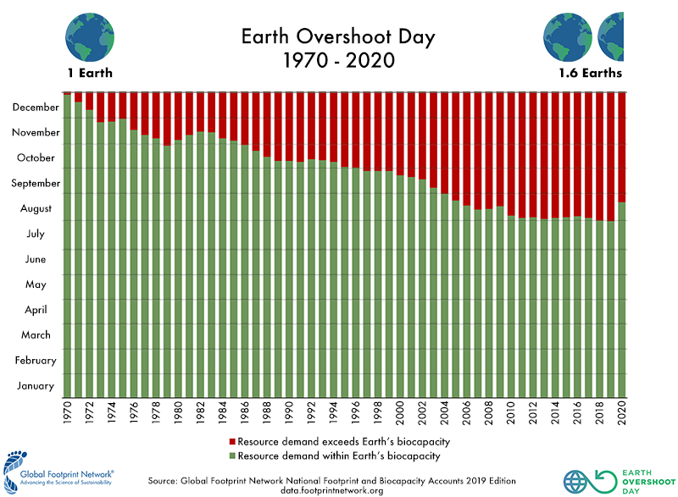

Describe the changes shown in the graph above.
The Impacts

What are the social, economic and environmental impacts of consumption exceeding the plant’s ecological resources?

Social impacts | Economic impacts | Environmental impacts
The Links

https://www.internetgeography.net/homework/synoptic-links-in-geography/
How does this Geography in the News link to what you have previously studied in geography and/or what you already know? How does this link to other aspects of geography?
The Next Level

Head over to https://www.overshootday.org Scroll down to find the section called Explore Solutions to #MoveTheDate. There are a range of solutions to #MoveTheDate. Select one of the five major areas for improving sustainability: planet, cities, energy, food or population and use dual coding to summarise the steps that can be taken. There is a guide to dual coding here: https://www.internetgeography.net/dual-coding/

