Geography in the News 2 (2020/21)
Wider reading in Geography
Geography in the News this week explores Hurricane Laura.
https://www.bbc.co.uk/news/world-us-canada-53959494
TinyURL: https://tinyurl.com/hurrilaura
Define It

To begin with, it will be very useful to know what the following terms mean. Write a definition for each:
- Tropical storm
- Hurricane

- Carbon monoxide poisoning

- Emergency generators

- Category 4 hurricane

- Displaced

The Facts

Using the BBC article above, complete the questions below or head over to https://www.internetgeography.net/2020gitn2/ to complete the questions as a multiple-choice quiz.
- How many people were without power and water following Hurricane Laura?
- How many people were killed by Hurricane Laura in the USA?
- Identify the two main US states affected by Hurricane Laura.
- What government assistance is being provided in some of the hardest-hit areas?
- What category was the storm when it hit the US state of Louisiana?
- How many houses are estimated to have been destroyed in Louisiana and Texas?
- True or false? There was more structural damage from winds than anticipated, but the water damage was less than feared.
- How many people have been deployed to help with rescue and clean up?
- Identify the immediate needs of people affected by the hurricane.
- Compare the impact of the storm on Haiti, one of the poorest countries in the world, compared to the USA.
Did the quiz online? What was your score? /10

The Map

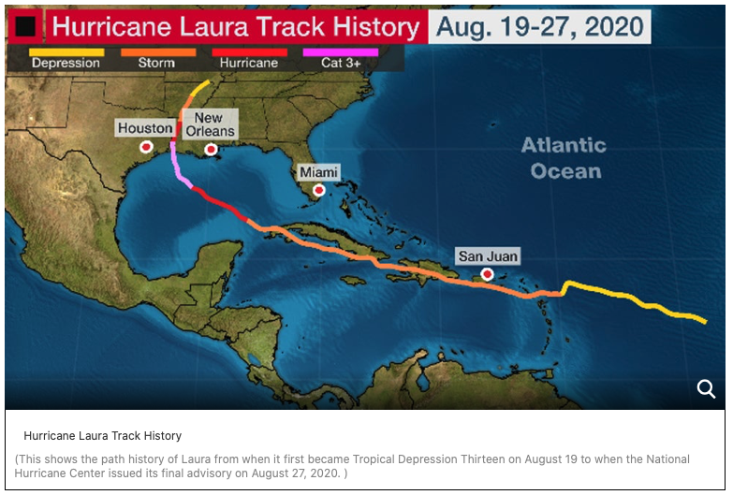
Arkansas
Louisiana
Texas
Cuba
Puerto Rico
Haiti
Dominican Republic
1. Using the map above, describe the track of Hurricane Laura between August 19th and August 27th 2020.
2. What happened to the wind speed between August 19th and August 27th 2020. Investigate why this happened.
The Impacts

What are the social, economic and environmental impacts of hurricanes?
Social impacts | Economic impacts | Environmental impacts
The Links

https://www.internetgeography.net/homework/synoptic-links-in-geography/
How does this Geography in the News link to what you have previously studied in geography and/or what you already know? How does this link to other aspects of geography?
The Next Level

Despite being weaker over Haiti, why did more people die there than in the USA?

