Geography in the News 3 (2020/21)
Wider reading in Geography
Geography in the News this week explores litter.
https://www.bbc.co.uk/newsround/54015196
Define It

To begin with, it will be very useful to know what the following terms mean. Write a definition for each:
- Litter
- Plastic pollution

- Landfill

- Incinerator

- Conservationists

- PPE

The Facts

Using the BBC Newsround article above, complete the questions below.

- How many disposable face masks and gloves are estimated to be being used every month around the world?
- Where are divers and observers spotting more PPE waste?
- Identify the charity that has seen an explosion of discarded masks and plastics on beaches and in rivers in the UK.
- What is most single-use PPE made from?
- How long can it take for masks, containing plastic, to breakdown in the sea?
- Why can’t most PPE be recycled?
- How is most PPE waste disposed of?
- Identify two items of PPE that form the new wave of plastic pollution.
- When did this new wave of plastic pollution start?
- What are conservationists recommending to reduce the amount of plastic waste from PPE?
Did the quiz online? What was your score? /10

The Graph

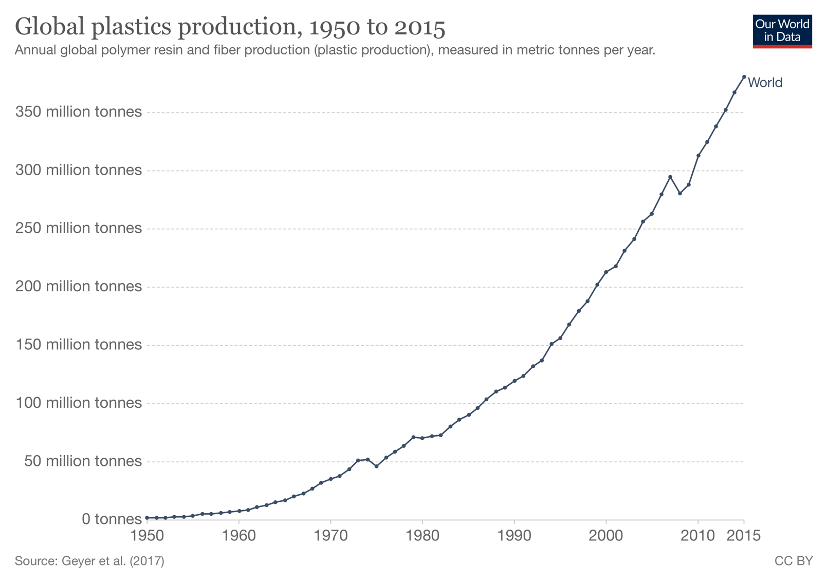
1. Describe global plastics production between 1950 and 2015.
The Impacts

What are the social, economic and environmental impacts of litter?
Social impacts | Economic impacts | Environmental impacts
The Links

https://www.internetgeography.net/homework/synoptic-links-in-geography/
How does this Geography in the News link to what you have previously studied in geography and/or what you already know? How does this link to other aspects of geography?
The Next Level

It’s the Great British September Clean between 11-27 September 2020. The campaign, by Keep Britain Tidy, is encouraging us to volunteer our time and either organise a group or individual clean up. Take some time to find out more here: https://www.keepbritaintidy.org
Why not get involved?

