Geography in the News 3 (2020/21)
Wider reading in Geography
Geography in the News this week explores Biodiversity: Why the nature crisis matters, in five graphics.
https://www.bbc.co.uk/news/science-environment-54357899
Define It

To begin with, it will be very useful to know what the following terms mean. Write a definition for each:
- Biodiversity
- Intergovernmental panel

- Extinction

- Over-fishing

- Sustainability

- Conservation

- Restoration

- International treaty

The Facts

Using the BBC article above, complete the questions below.
- According to an intergovernmental panel of scientists how many plant and animal species are now threatened with extinction?
- How did global populations of mammals, birds, fish, amphibians and reptiles plunge by, on average, between 1970 and 2016?
- What are scientists warning we are entering?
- How are humans pushing other species to extinction?
- How many species of mammals are predicted will be lost this century?
- How are humans transforming the natural landscape?
- Give three problems caused by habitat change?
- Identify three ways biodiversity can be restored.
- Identify the international treaty for conservation that countries agreed 10 years ago.
- What were the three main aims of the international treaty?
- How successful were countries in meeting the targets of the convention?
- What are world leaders now being asked to agree to?
The Graph

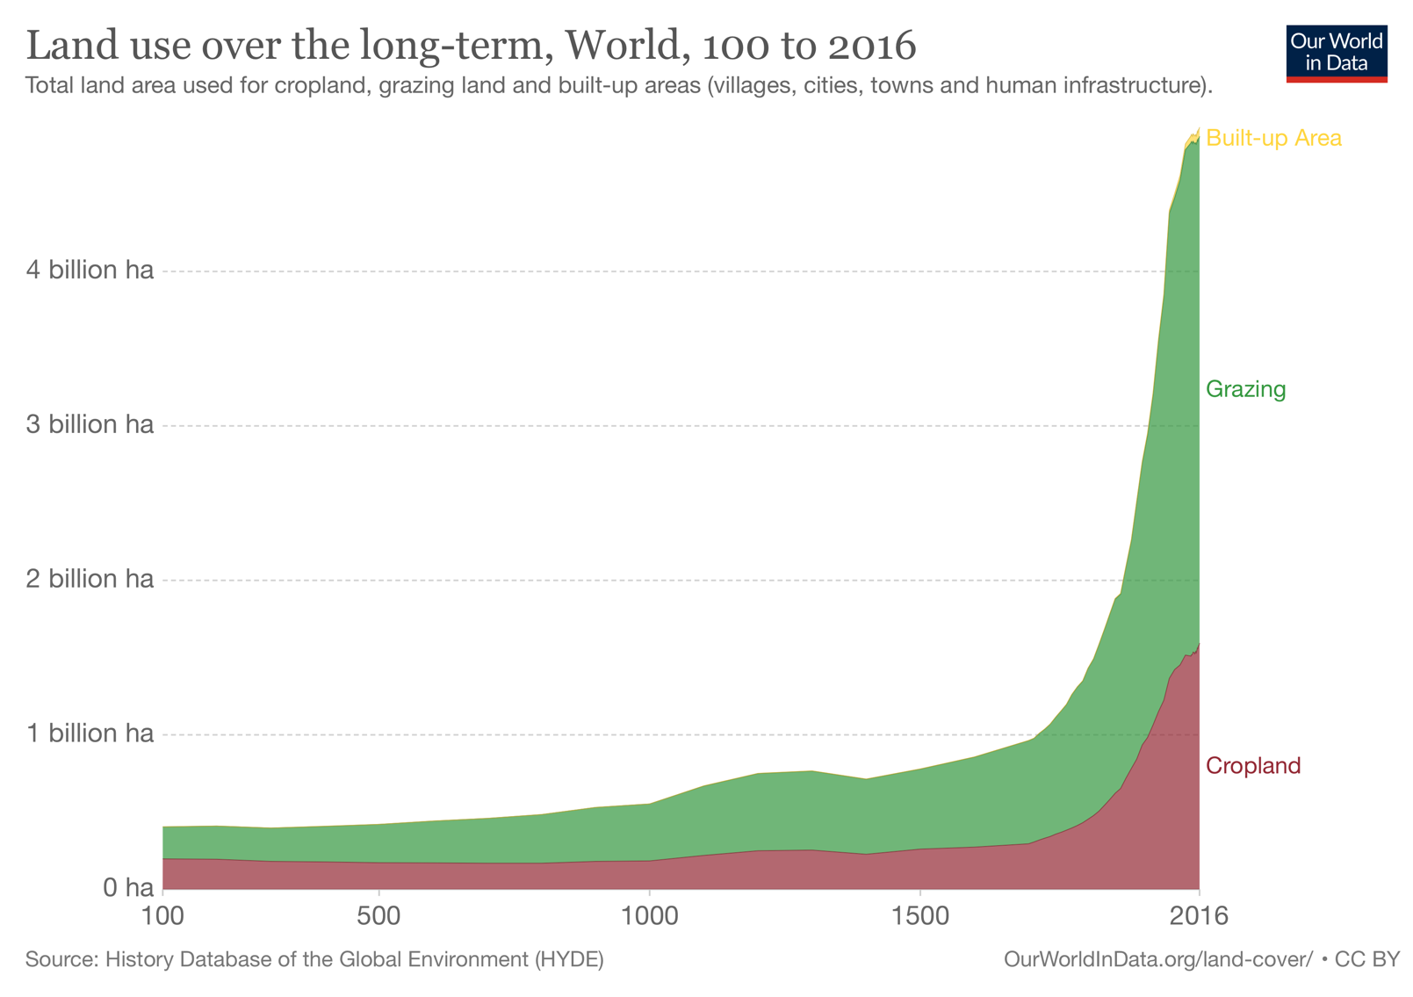
1. Describe changes in landuse shown in the graph above.
The Impacts

What are the social, economic and environmental impacts of biodiversity loss?
Social impacts | Economic impacts | Environmental impacts
The Links

https://www.internetgeography.net/homework/synoptic-links-in-geography/
How does this Geography in the News link to what you have previously studied in geography and/or what you already know? How does this link to other aspects of geography?
The Next Level

Head over to https://www.bbc.co.uk/news/science-environment-48169783 Produce a graphic (like some of those on the first article you looked at) to show data relating to the nature crisis. Take a photo or screenshot and send over to admin@internetgeography and we’ll share some of our favourites.

