Geography in the News 5 (2020/21)
Wider reading in Geography
Need help?
If you need advice on any of the activities in this assignment, please visit
www.internetgeography.net/gitn5help
This week Geography in the News explores a coastal defence project
in Withernsea on the Holderness Coast, East Yorkshire.

Read the article and watch the video on:
https://www.internetgeography.net/new-sea-defences-at-withernsea
or tinyurl.com/Withernsea
The Definitions
To begin with, it will be very useful to know what the terms below mean. Write a definition for each:
- Coast

- Coastal erosion

- Sediment

- Longshore drift

- Coastal defences

- Rock armour

- Neap tide
The Location

Label the location of Withernsea on the two maps below.
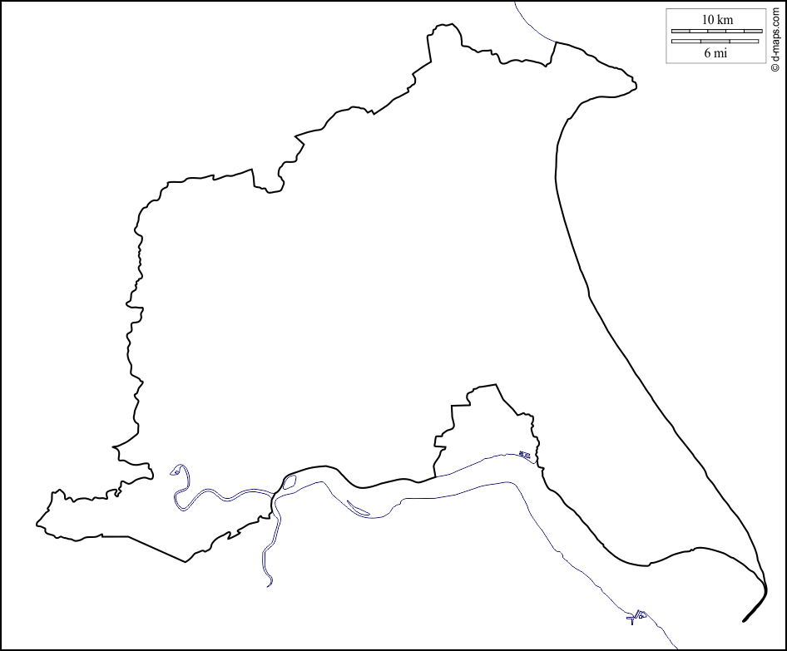
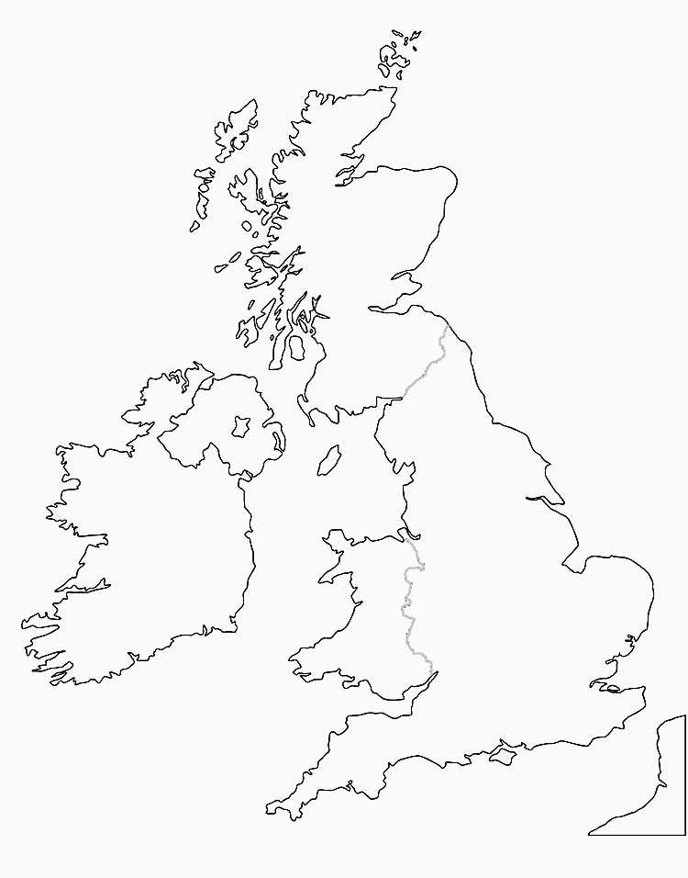
The Site and Situation

Describe the site and situation of Withernsea.

Site:

Situation:

The Sense of Place

Take a virtual trip to Withernsea using Google Street view. What are the human and physical characteristics of Withernsea? Give a description of your experience of visiting the town.

Human Features | Physical Features

Description:

The Facts

Either complete the questions below or take the quiz on internetgeography.net/gitn5quiz
- Identify three types of coastal defences at Withernsea.
- Which type of coastal defence involves trapping sand, being transported by longshore drift, to form a wide sandy beach?
- How have the sea defences been extended to the south of Withernsea?
- What has happened to the rate of erosion along the boulder clay cliffs to the south of Withernsea?
- True or false? To the south of Withernsea rates of erosion have increased because there is very little sediment to form a wide beach.
- What name is given to the notch-shaped bays that form to the south of the defences?
- What rate of erosion has been recorded to the south of defences at Withernsea?
- How far has the rock armour at Withernsea been extended?
- How much rock armour was imported from Norway?
- How much do the individual pieces of rock weigh?
- True or false? The boulders were used to create an interlocking rock structure, designed to prevent the sea from eroding the cliffs. This is thought to be amongst the largest used in such defences around the UK.
- What happened to the cliffs before the rock armour was installed?
- When was the project completed?

The Data

Installing the 400m stretch of rock armour cost £7 million. How much did it cost per metre? (show your working out)

The distance between Withernsea and the next coastal settlement (Easington) is 8km. How much would it cost to extend the defences from Withernsea to Easington? (show your working out)

The Image

Using the photograph titled Completed coastal defences at Withernsea on 17th December 2020, either produce an annotated sketch of the photograph or copy and paste the image below and annotate it.
Top tip: The image titled Withernsea – Terminal Groyne Effect is labelled. You need to annotate your image. An annotation is a fairly detailed explanation or comment added to photographs, diagrams, sketches or maps to explain, elaborate or emphasise particular features.

The Justification

Give the social, economic and environmental reasons for extending the coastal defences at Withernsea.

Social | Economic | Environmental

The Links

https://www.internetgeography.net/homework/synoptic-links-in-geography/
How does this Geography in the News link to what you have previously studied in geography and/or what you already know? How does this link to other aspects of geography?

The Next Level

What do you predict will happen along this stretch of coastline in the future? Give reasons for your answer.

