Geography in the News 6 (2020/21)
Wider reading in Geography
Geography in the News this week explores South Korea’s declining population.
https://www.internetgeography.net/population-changes-in-south-korea/
TinyURL: https://tinyurl.com/skpopn
Define It

To begin with, it will be very useful to know what the following terms mean. Write a definition for each:
- Population
- High-income country

- Birth rate

- Ageing population

- Life expectancy

- Dependency ration

- Population pyramid

- Demographic transition model

- Fertility rate

The Facts

Using the article above, complete the questions below.
- What has happened to South Korea’s population for the first time in its history?
- What impact does an ageing population have on a country’s dependency ratio?
- How much did South Korea’s population decrease by in 2020?
- If the current population trend continues, what will South Korea’s population be in 2067? How much lower will this be compared to 2020?
- How many years has life expectancy in South Korea increased by between 1950 and 2020? (you will need to do a calculation)
- True or false? South Korea has the lowest fertility rate in the world.
- What is the difference between South Korea’s fertility rate and the global average? (you will need to do a calculation)
- Give one reason why South Korea’s population is in decline.
- Identify one problem associated with South Korea’s ageing population.
- What is being done to address South Korea’s ageing population?

The Model

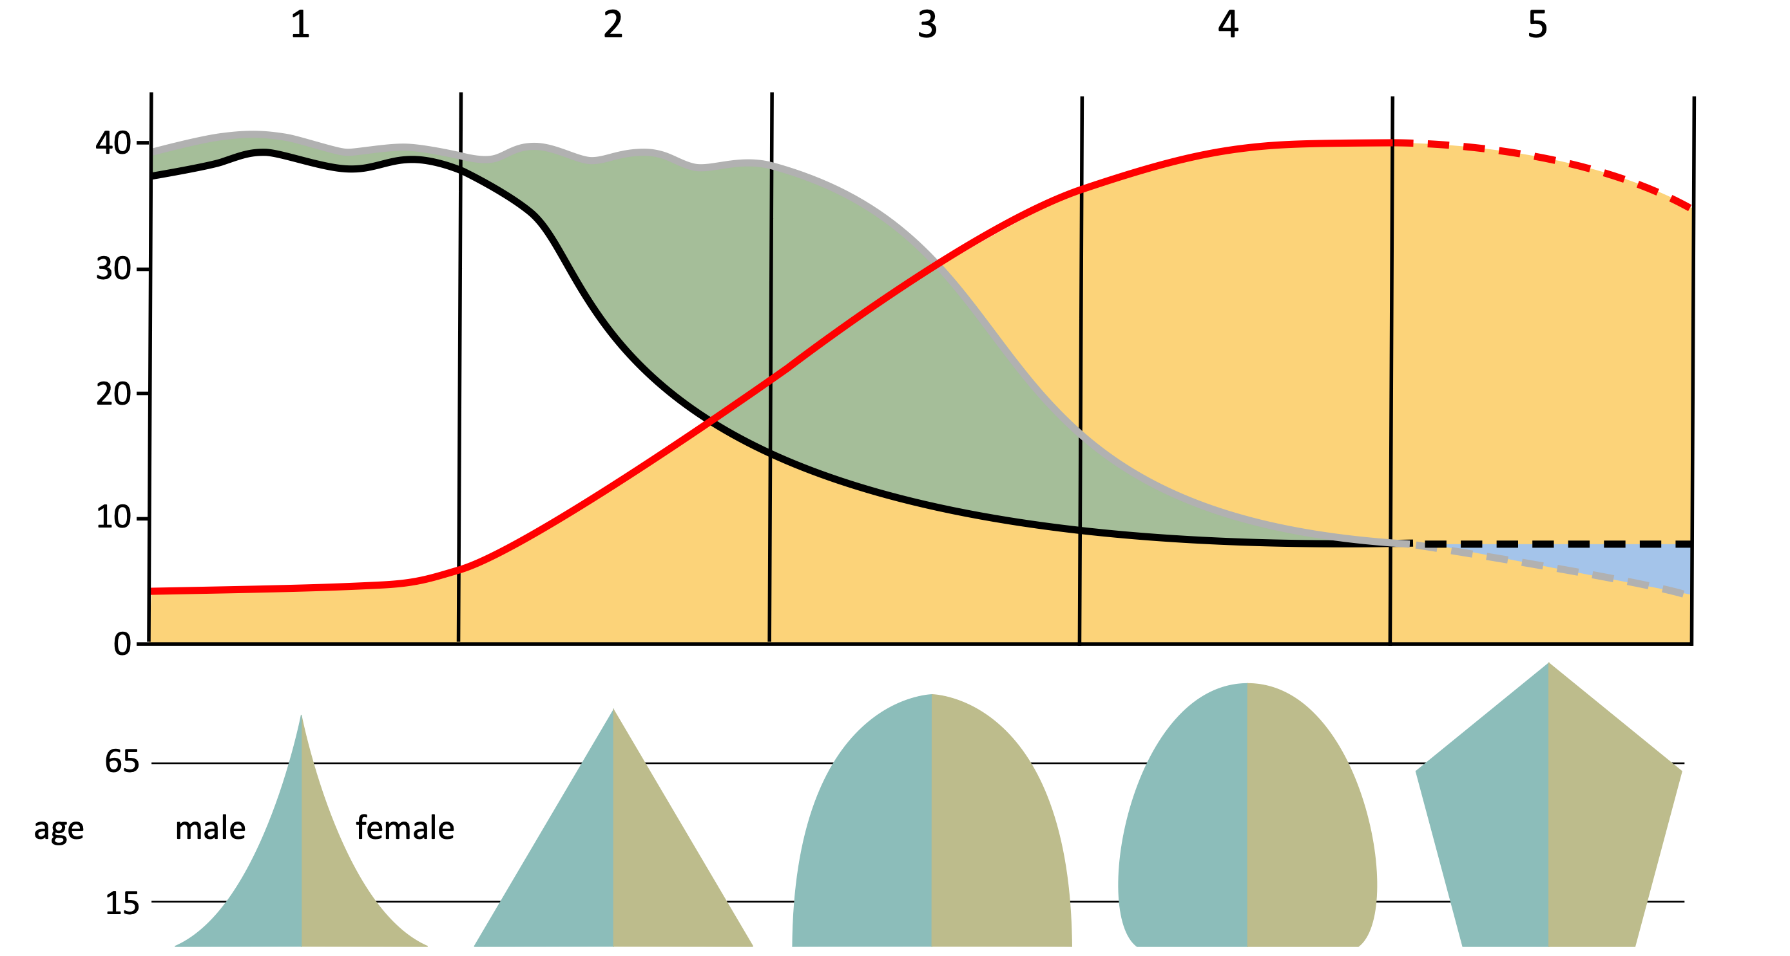
1. Identify the stage where South Korea is on the demographic transition model. Give reasons for your answer
The Impacts

What are the social and economic impacts of an ageing population?
Social impacts | Economic impacts
The Links

https://www.internetgeography.net/homework/synoptic-links-in-geography/
How does this Geography in the News link to what you have previously studied in geography and/or what you already know? How does this link to other aspects of geography?
The Next Level

Why are models, such as the demographic transition model, useful for geographers?

