Geography in the News 7 (2020/21)
Wider reading in Geography
Geography in the News this week explores the impact of washing your clothes on the Arctic.
https://www.internetgeography.net/how-does-washing-your-clothes-lead-to-plastic-pollution-in-the-arctic/
TinyURL: https://tinyurl.com/pparctic
To begin with, it will be very useful to know what the following terms mean. Write a definition for each:
Define It

- Microplastic
- Microplastic fibres

- Synthetic clothing

- Polyester clothing

- Mariana Trench

- Ocean current

- North Atlantic Drift

- Zooplankton

The Facts

Using the article above, complete the questions below.
- Where have high levels of polluting, microplastic fibres recently been found?
- Which two continents are largely responsible for the increase in Arctic microfibres?
- What proportion of the microplastics were found to be fibres?
- What proportion of the microplastic fibres can from polyester clothing?
- Why is the 3-8m layer of sea water so important?
- What other extreme environments are experiencing plastic pollution?
- From which ocean are most microplastic fibres entering the Arctic?
- Identify the ocean current responsible for transporting microplastic fibres to the Arctic.
- What is the impact of zooplankton consuming microplastics?
- Identify three things we can do to reduce the release of microplastics into oceans.
The Graph

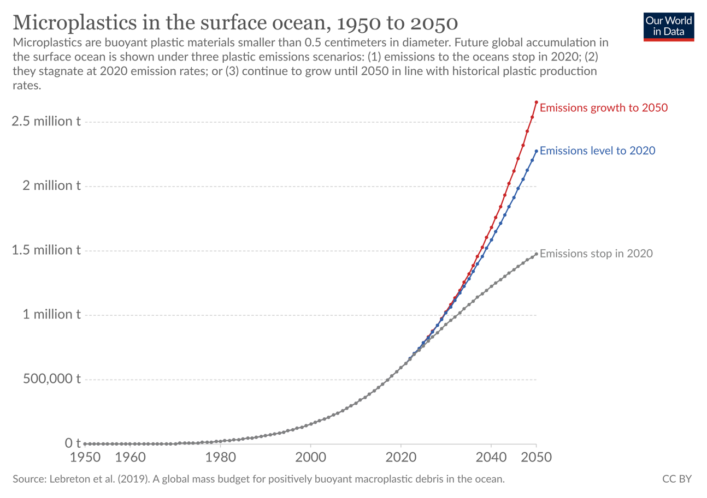
You can view an interactive copy of this graph here: https://ourworldindata.org/grapher/microplastics-in-ocean

1. Describe what will happen to microplastic levels in the surface ocean if emissions continue to grow at the the current rate shown by the red line on the graph.
The Impacts

What are the environmental and economic impacts of microfibres being released into the world’s oceans?
Environmental impacts | Economic impacts
The Links

https://www.internetgeography.net/homework/synoptic-links-in-geography/
How does this Geography in the News link to what you have previously studied in geography and/or what you already know? How does this link to other aspects of geography?
The Next Level

What can industry do to reduce the levels of microplastic fibres being released into the world’s oceans?

