Geography in the News 8 (2020/21)
Wider reading in Geography
Geography in the News this week explores Storm Christoph.
https://www.internetgeography.net/storm-christoph/
TinyURL: https://tinyurl.com/stormchristoph
To begin with, it will be very useful to know what the following terms mean. Write a definition for each:
Define It

- Atlantic Depression
- Low-pressure system

- Flood alert

- Flooding

- Environment Agency

- Sinkhole

- Drainage basin

The Facts

Using the article above, complete the questions below.
- How many named storms have occurred before Storm Christoph?
- What type of weather system was Storm Christoph?
- What was the main threat of Storm Christoph?
- How many of the ten places with the most rainfall were located in Wales?
- Identify the type of weather warning issued for Storm Christoph.
- How many flood warnings and alerts were issued across England?
- How was the village of Fishlake prepared for Storm Christoph?
- Which areas were the worst affected by Storm Christoph?
- According to the Environmental Agency, how many homes were flooded as a result of Storm Christoph?
- How many homes were protected by the actions of the Environmental Agency?
- What is the estimated insurance cost of Storm Christoph?

The Photo

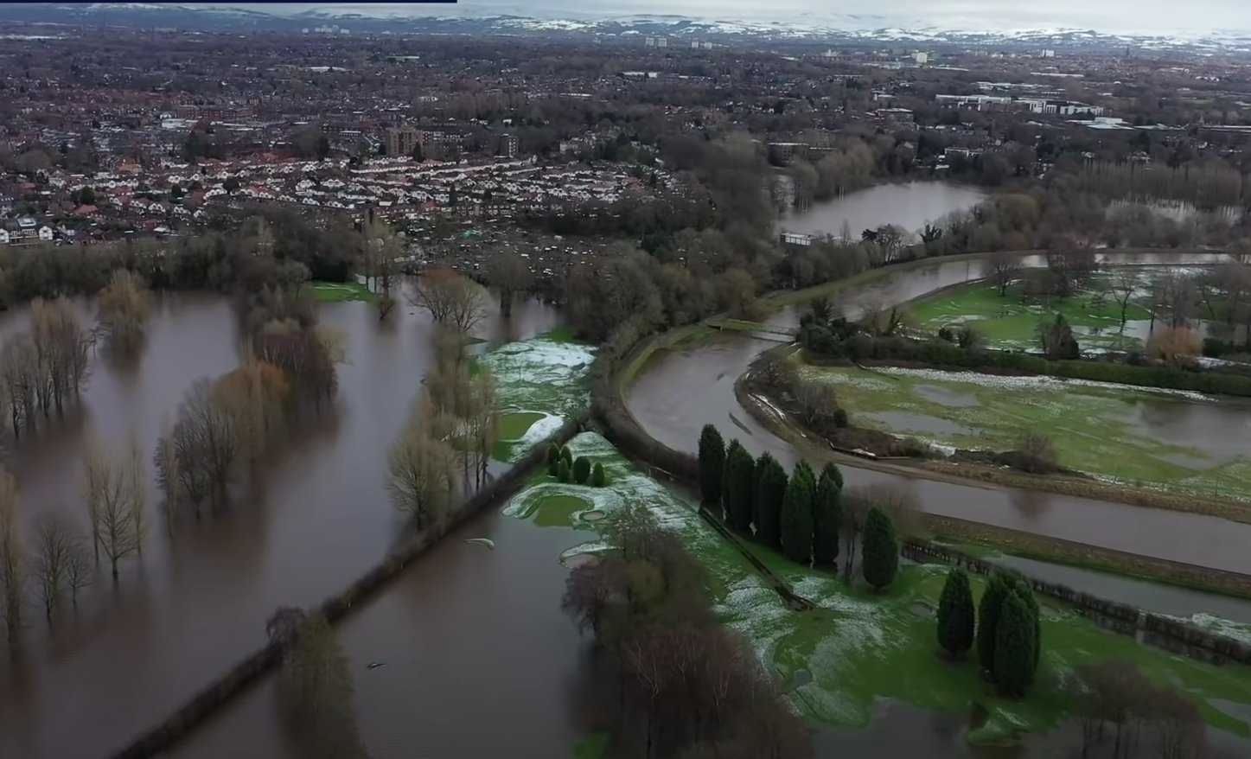
The image above shows the impact of flooding in Manchester. Either produce an annotated sketch of the photograph or add annotations to the image (draw text boxes and arrows).

Tip: Be sure to identify features such as levees, river channel, land use that has bee flooded, land use that is at risk of flooding etc.
The Impacts

What are the social and economic impacts of Storm Christoph?
Social impacts | Economic impacts
The Links

https://www.internetgeography.net/homework/synoptic-links-in-geography/
How does this Geography in the News link to what you have previously studied in geography and/or what you already know? How does this link to other aspects of geography?
The Next Level

How can leaky dams reduce the risk of flooding?

