Geography in the News 9 (2020/21)
Wider reading in Geography
Geography in the News this week explores the ten golden rules for tree-planting.
https://www.internetgeography.net/ten-golden-rules-for-tree-planting/
TinyURL: https://tinyurl.com/10grules
To begin with, it will be very useful to know what the following terms mean. Write a definition for each:
Define It

- Climate Change

- Reforestation
- Biodiversity

- Pristine tropical rainforest

- Desertification

- Natural forests

- Commercial plantations

- Afforestation

The Facts

Using the article above, complete the questions below.
- How many golden rules for planting trees have been proposed by scientists at Kew?
- Give two reasons for planting trees.
- What proportion of the world’s plants and animals live in forests?
- How much new forests is the UK government proposing to plant each year before the next parliament?
- Identify the continent where a great green wall of trees is being planted.
- Identify two countries the great green wall will cross.
- True or false? Commercial plantations are an effective way of restoring natural forests.
- True or false? Working with local people is an example of the 10 golden rules.

The Choropleth Map

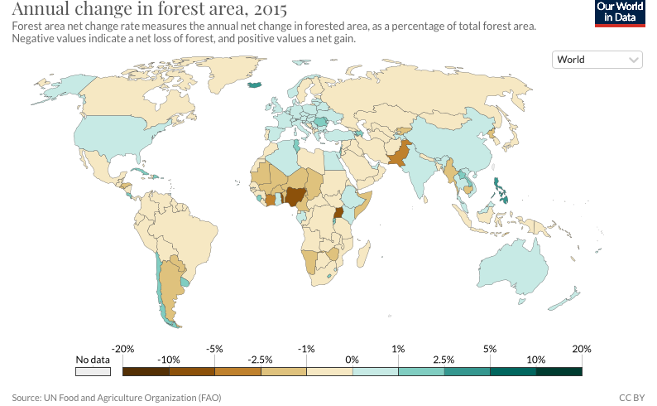
The choropleth map above shows the annual change in forest cover for each country.

Describe the distribution of forest change shown on the choropleth map.

If you need help doing this scroll to the bottom of the web page with the news article on Internet Geography. There is a step-by-step guide to answering this question and an interactive version of the map.
The Impacts

What are the social and environmental benefits of the 10 golden rules of tree-planting?
Social impacts | Environmental impacts
The Links

https://www.internetgeography.net/homework/synoptic-links-in-geography/
How does this Geography in the News link to what you have previously studied in geography and/or what you already know? How does this link to other aspects of geography?
The Next Level

Rank the 10 golden rules of tree-planting in order of which you think are most important. Give reasons for your choices.

