Geography in the News 10 (2020/21)
Wider reading in Geography
Geography in the News this week explores Iceland’s vanishing glaciers.
https://www.bbc.co.uk/news/science-environment-55346329
TinyURL:
To begin with, it will be very useful to know what the following terms mean. Write a definition for each:
Define It

- Ice cap

- Glacier

- Glacial retreat
- Climate change

- Ice core

- CO2

- Altitude

- Precipitation

The Facts

Using the article above, complete the questions below.
- What is the name of Iceland’s ice cap, that is Europe’s largest glacier?
- What is the name of the glacier that features in the article and flows from the ice cap?
- What does Vatnajökull mean? (you’ll need to search this on the Internet)
- What does Skaftafellsjökull mean? (you’ll need to search this on the Internet)
- How much is it estimated that the glacier has shrunk by in the last 30 years?
- What is the cause of the shrinking glacier?
- What are considered to be among the most visual indicators of how the world's climate is warming?
- Since 1980, the equivalent of how many metres of ice have been ‘sliced’ off the surface of the average glacier?
- What factors affect the rate of glacier melt?
- True or false? Glaciers provide a valuable record of past climates.
- How do ice cores provide a year-by-year record of past climates?
- Identify two impacts of melting glaciers.

The Graph

The graphs on the left show the balance of three Icelandic glaciers. The blue bars show the snow that accumulates in the winter and the red bars show the snow and ice melted over the summer. The line on each graph shows the mass balance (difference between the accumulated snow and melted snow and ice). Where the line is above 0, the mass balance is positive because the glacier grows because it accumulates snow and ice. Where the line is below 0 the mass balance is negative which means the glacier is shrinking because melt is higher than accumulation.
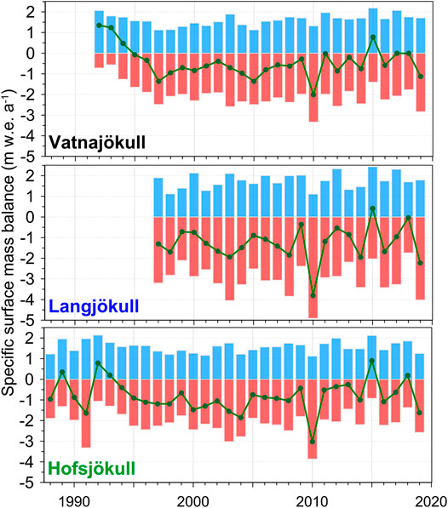

Using the graphs above complete the table below
The Links

 | Number of years with a positive mass balance | Number of years with a negative mass balance
Vatnjökull
Langjökull
Hofsjökull

https://www.internetgeography.net/homework/synoptic-links-in-geography/
How does this Geography in the News link to what you have previously studied in geography and/or what you already know? How does this link to other aspects of geography?
The Next Level

Explain how ice cores are used to study past climate?

