Geography in the News 3 (2021/22)
Wider reading in Geography
Geography in the News this week explores climate change: World now sees twice as many days over 50°C. Read the article here:
https://www.bbc.co.uk/news/science-environment-58494641
TinyURL: https://tinyurl.com/twice50
Define It

To begin with, it will be very useful to know what the following terms mean. Write a definition for each:
- Climate change
- Unprecedented
- Storm surge

- Fossil fuel emissions

- Drought
- Wildfires

- Desertification
The Facts

Using the article above, complete the questions below.
- The number of hot days when temperature reaches 50°C has doubled since when?
- On average, between 1980 and 2009 how many days a year experienced temperatures over 50°C?
- On average, between 2010 and 2019 how many days a year experienced temperatures over 50°C?
- What is the main cause of the increase in the number of days over 50°C?
- Where do temperatures of 50°C predominantly happen?
- What will governments be asked to do at the UN Climate Change Summit in Glasgow in Nov 2021?
- How many people could experience heat stress conditions by 2100?
- Identify one impact on increased temperatures in central Iraq.

The Impacts
Complete the table below to show the social, economic and environmental impacts of climate change (you may need to do additional research).
Social Impacts | Economic Impacts | Environmental Impacts
The Graph

Study the graph showing changes in global average temperatures between 1850 and 2019.
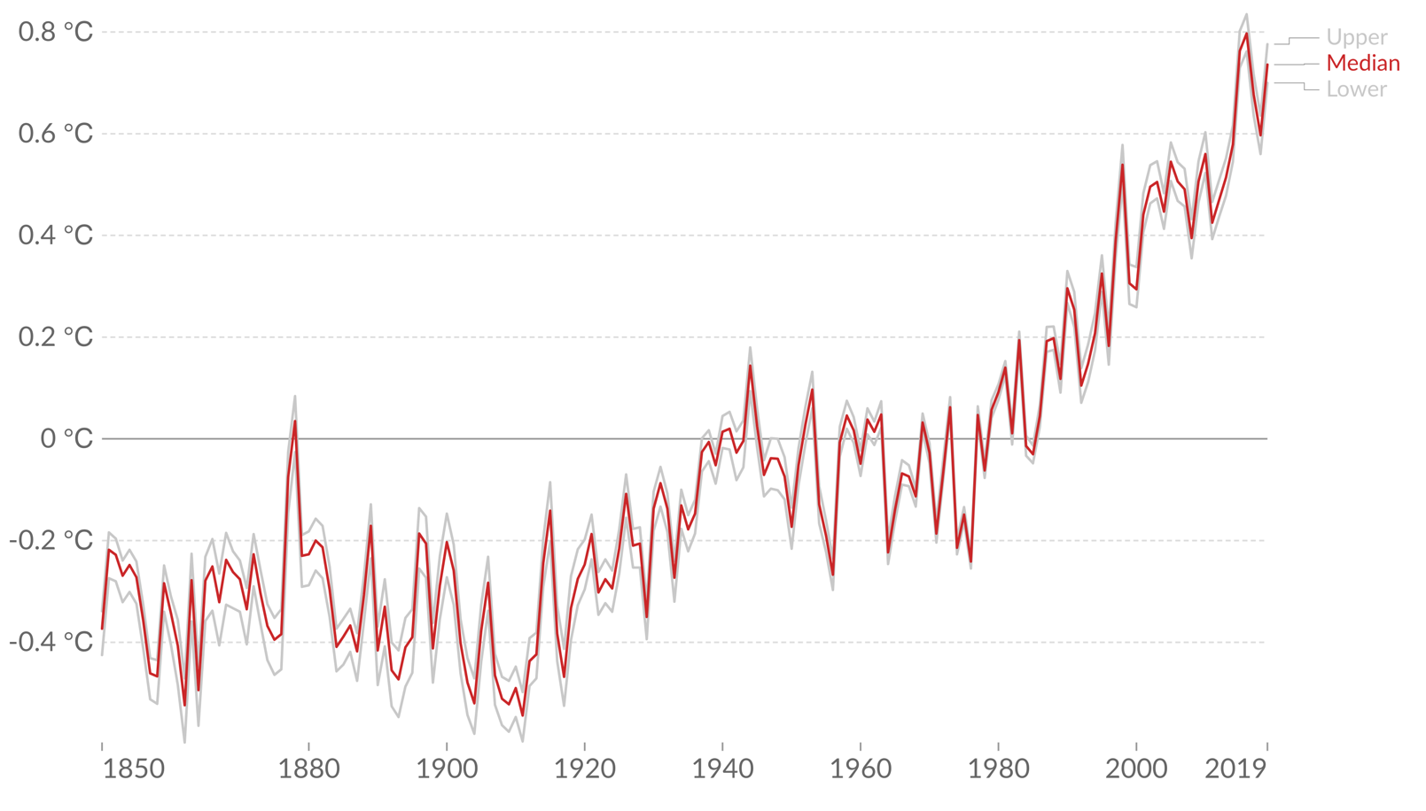
Describe the changes in global average temperatures shown on the graph.

