E-PLCs User Guide – Copy and Paste Technique

Step 1
Click the link for the required PLC on Internet Geography Plus. You will be asked if you want to make a copy. Click OK.

This will copy the Google Form and Google Sheet to your drive. The spreadsheet will open.

Step 2

Go to Google Drive. Create a folder for your E-PLCs. Locate the two new documents and drag and drop them into your new folder. The sheet will be listed in your home drive. The Google Form might need locating (it sometimes gets saved in a recent folder you have used. If you can’t find it use the search tool – the name of the Form will be Copy of xxxxxxxxxxxxxxxxxxxxxxxxx – with x being the name of the spreadsheet – so for rivers you would search for Copy of River Landscapes in the UK)

In this example we will use the River Landscapes in the UK E-PLC.
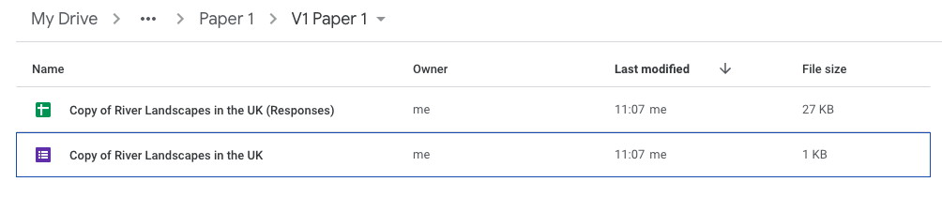

Step 2
Rename the Sheet and Form by right clicking on each and select rename. In the example below we have removed Copy of.

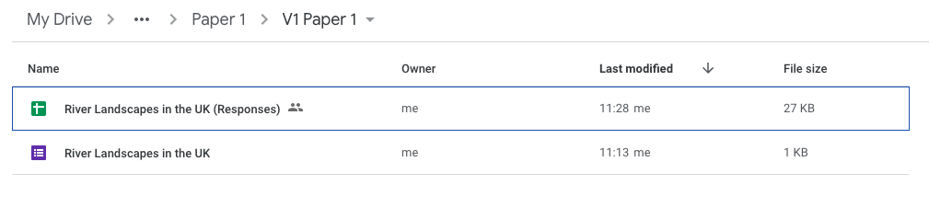

Step 3 – Sharing the form with students
Open the Form. Click the Preview (eye) icon. This will open the form for students to complete. Copy the web address and share with your students.


Step 4 – View results
To view the results as students complete the E-PLC open the Google Sheet. Click the Class Overview tab to view the results for the class. Clicking the Student 1 tab will display the PLC for the first student to complete the PLC form. You can rename this to the name of the student.

There are student tabs for the first 30 students to complete the PLC. If you have more than 30 students right click on the last student tab and select Duplicate. This will create a copy. Rename it e.g. Student 31.
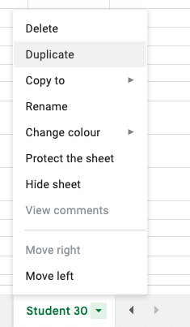

You then need to go to Cell B3 and change the contents by adding one to the formula e.g. =Query!B31 should become =Query!B32.

Replace the formula in A4 in the same way.

Next, the formulas in column B also need changing in the same way.

